# 20170303
# Two HDD were taken from other server.
# It were used in raid on that server.

# After these two HDD were added into our target server, I’ve seen follow.
# I cannot do anything with these drives… All options were unavailable for them.
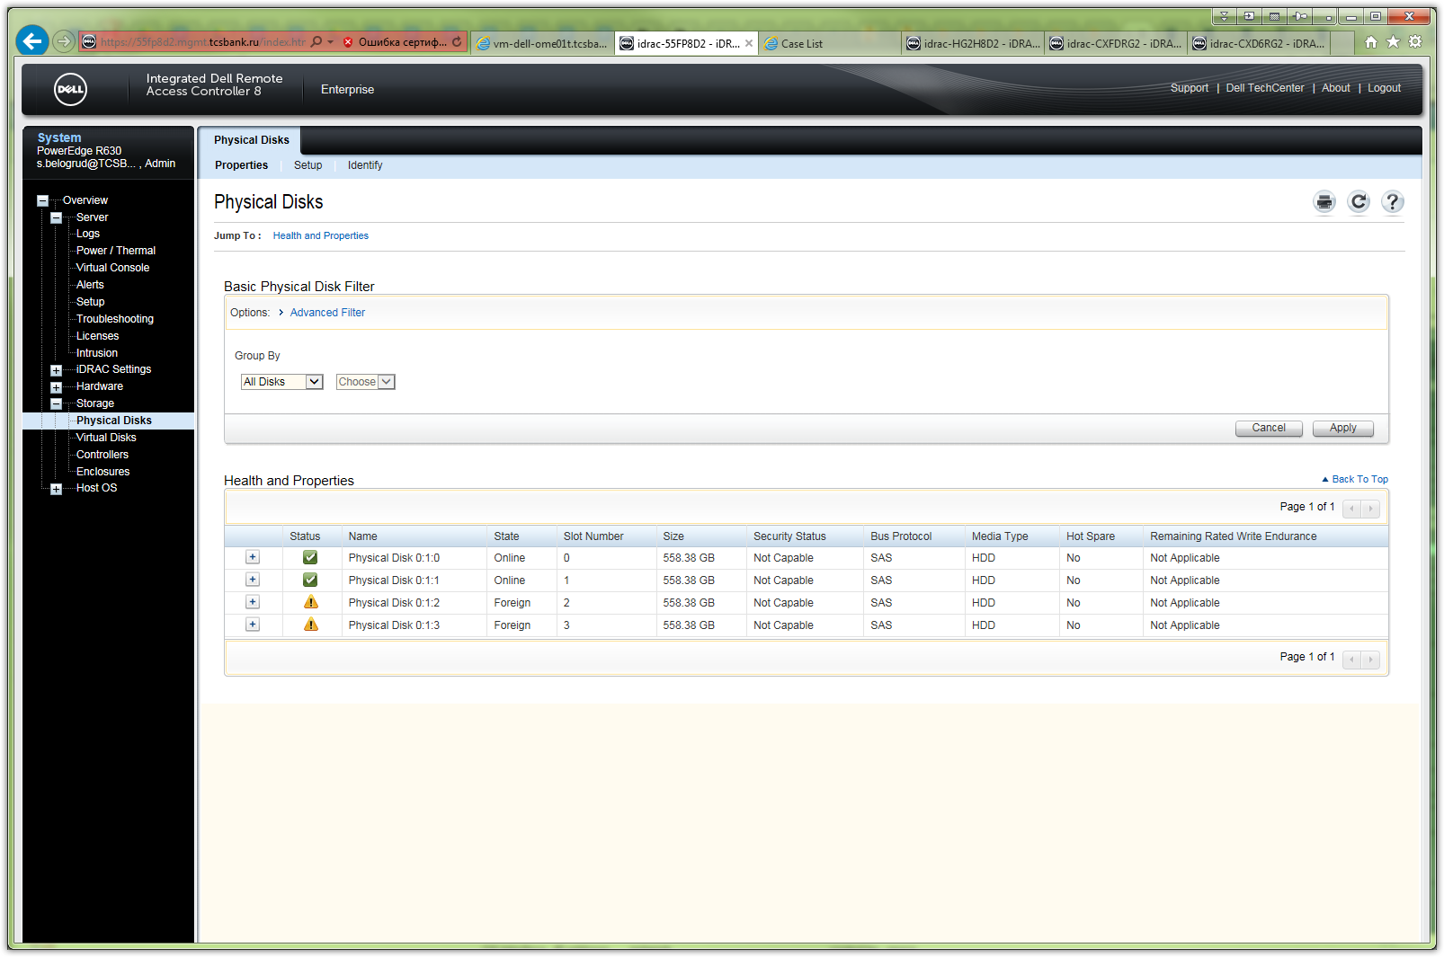

# During system boot I saw follow messages about “Foreign” drives.
# My attempts to press “F” button was unsuccessful. It was not help me.
# Usefull way is to press “Ctrl+R” buttons to run raid configuration utility.
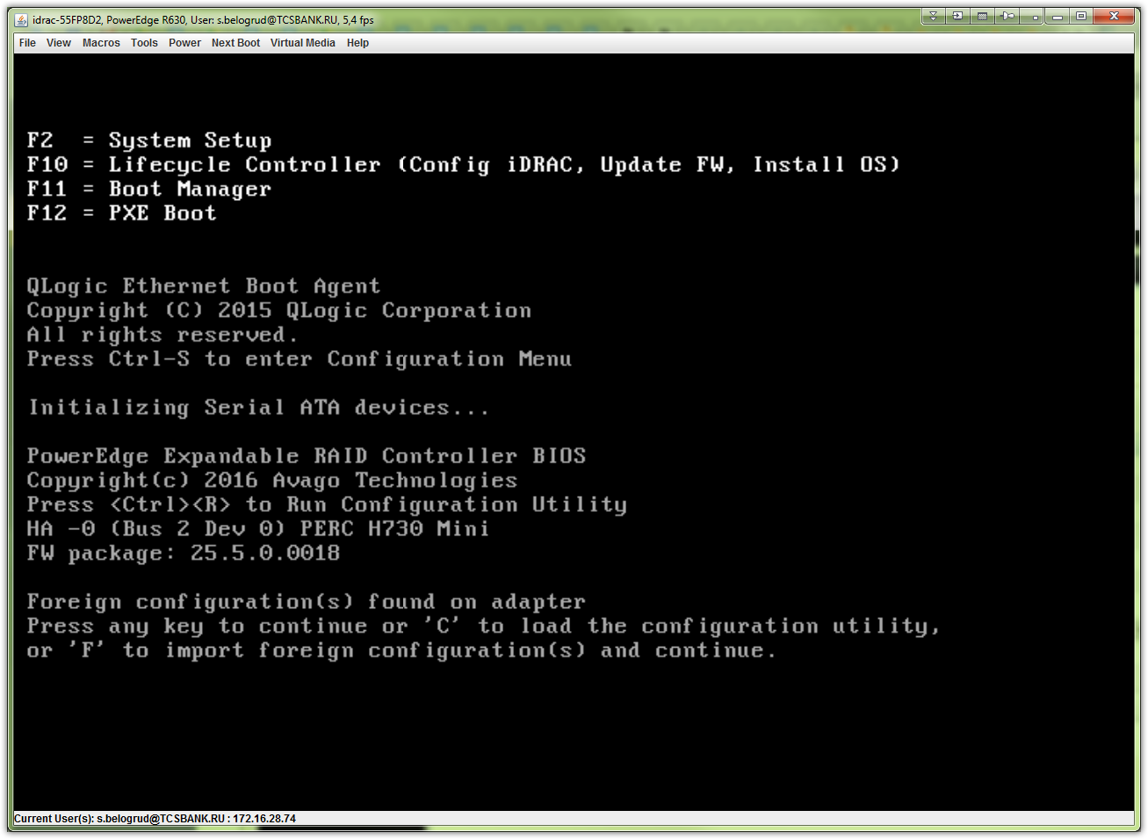

# Follow are what I see after entering into raid controller configuration utility.
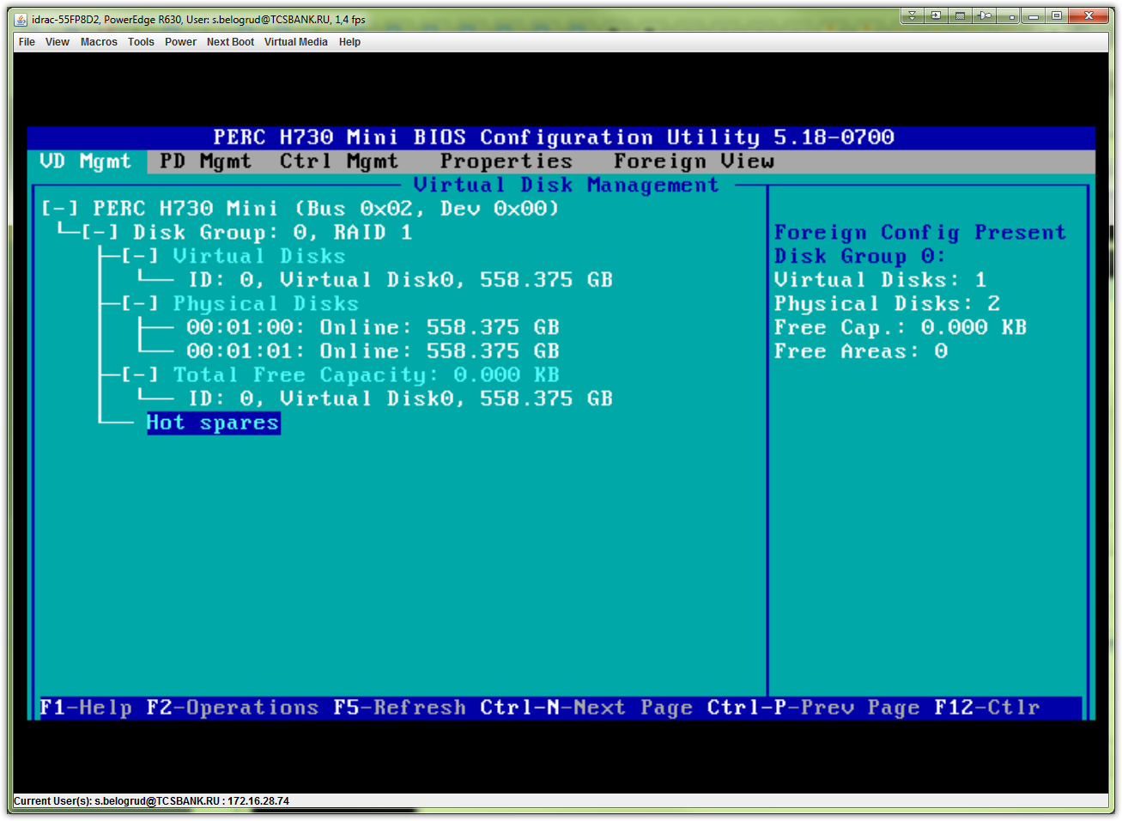
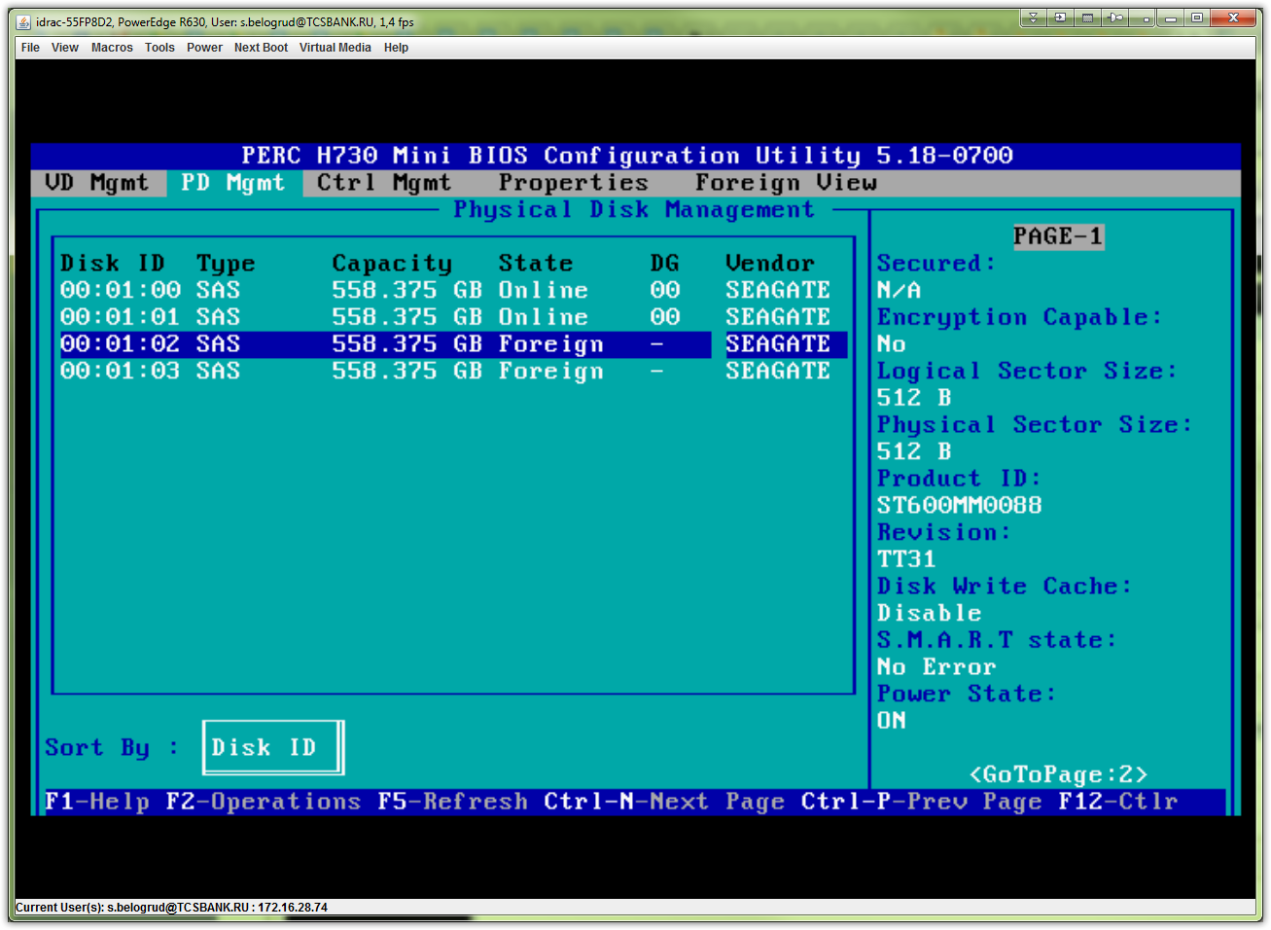
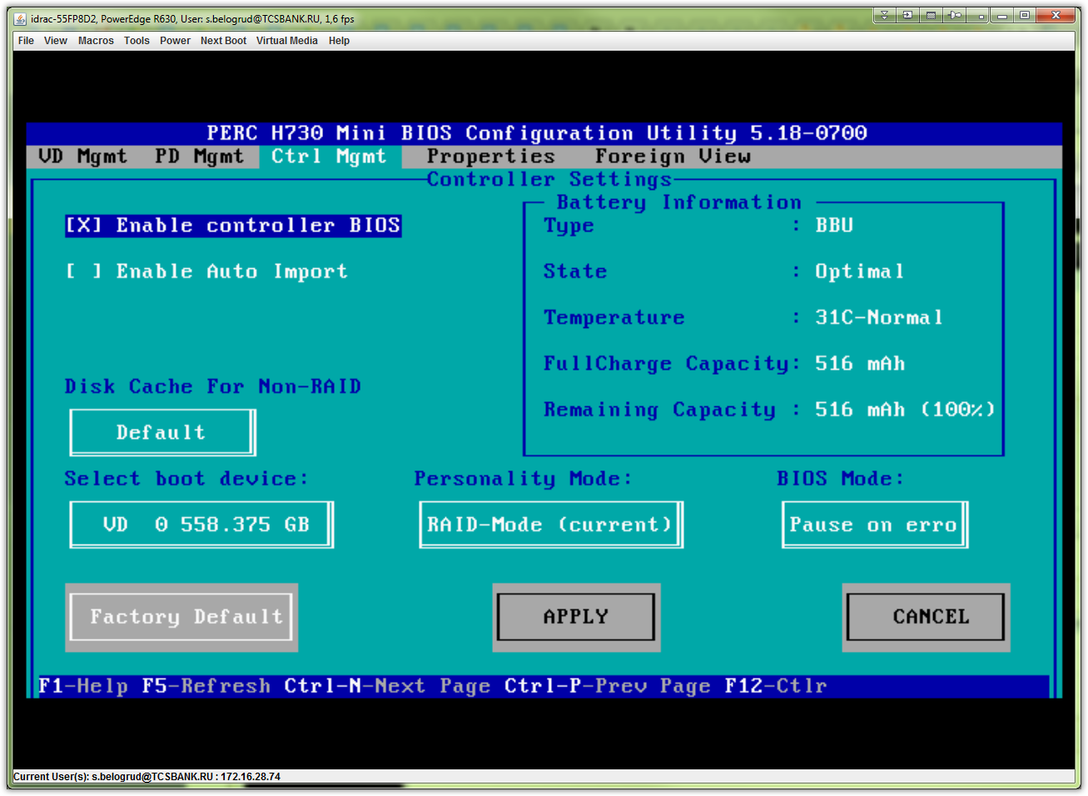
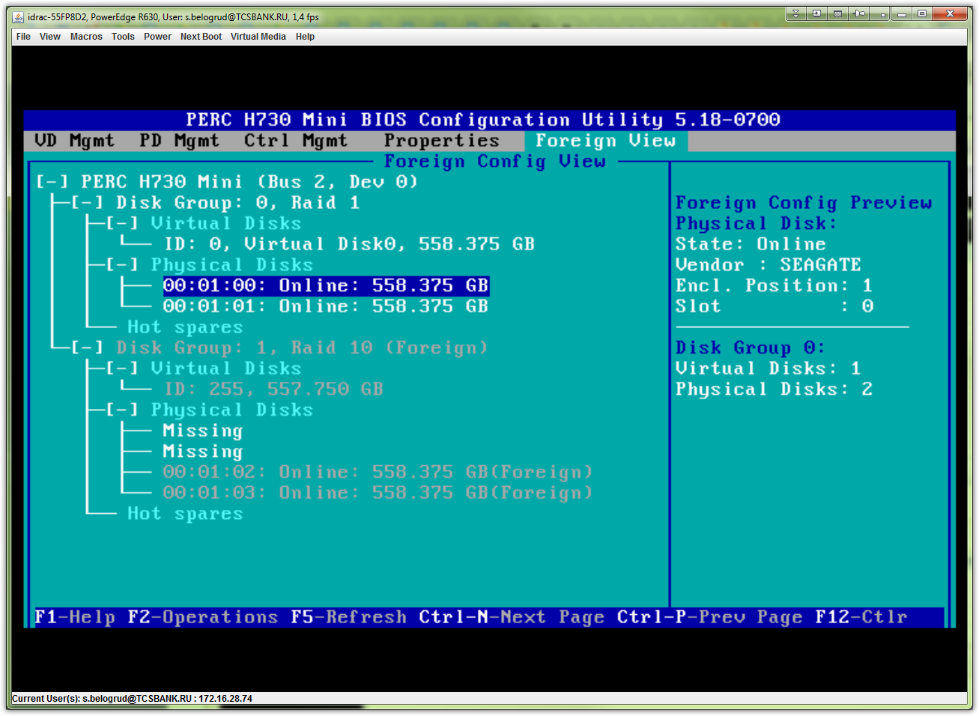

# Right behavior is to choose “Clear” option!
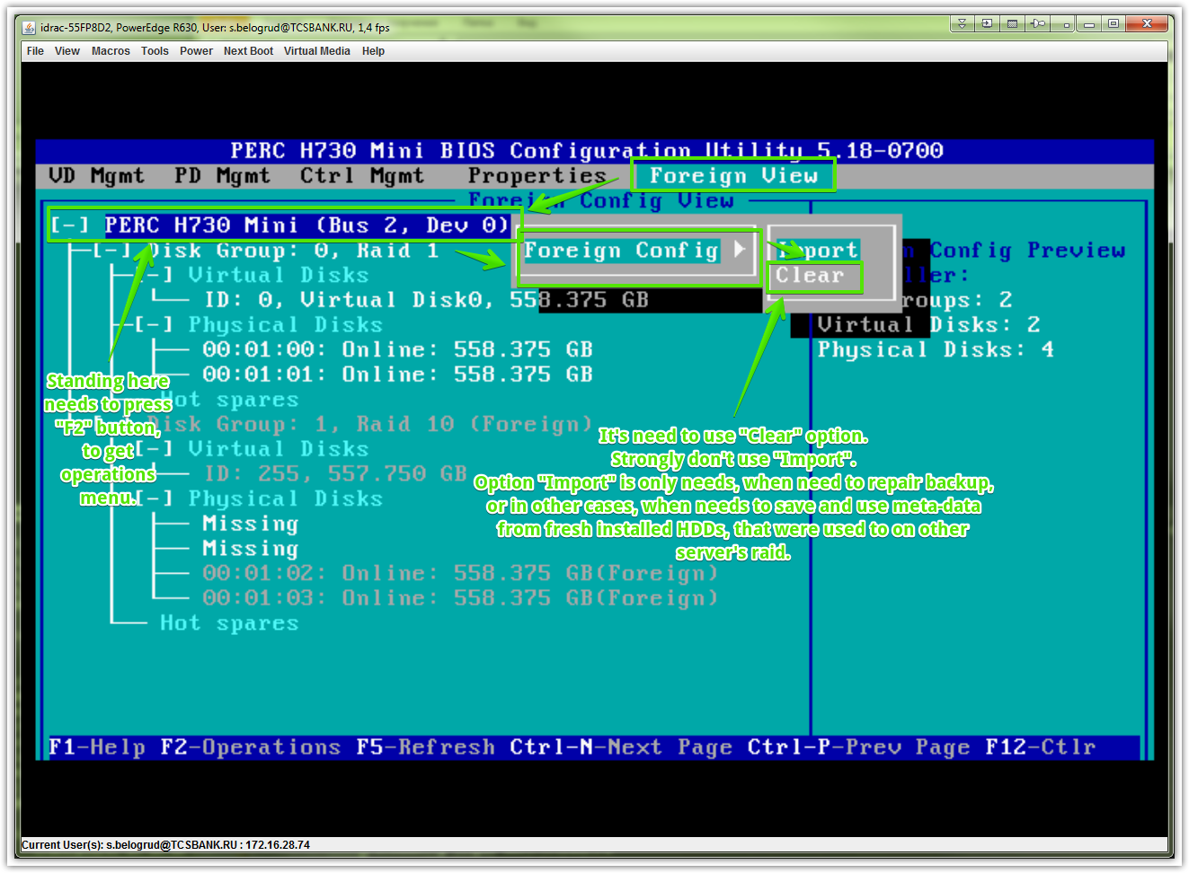
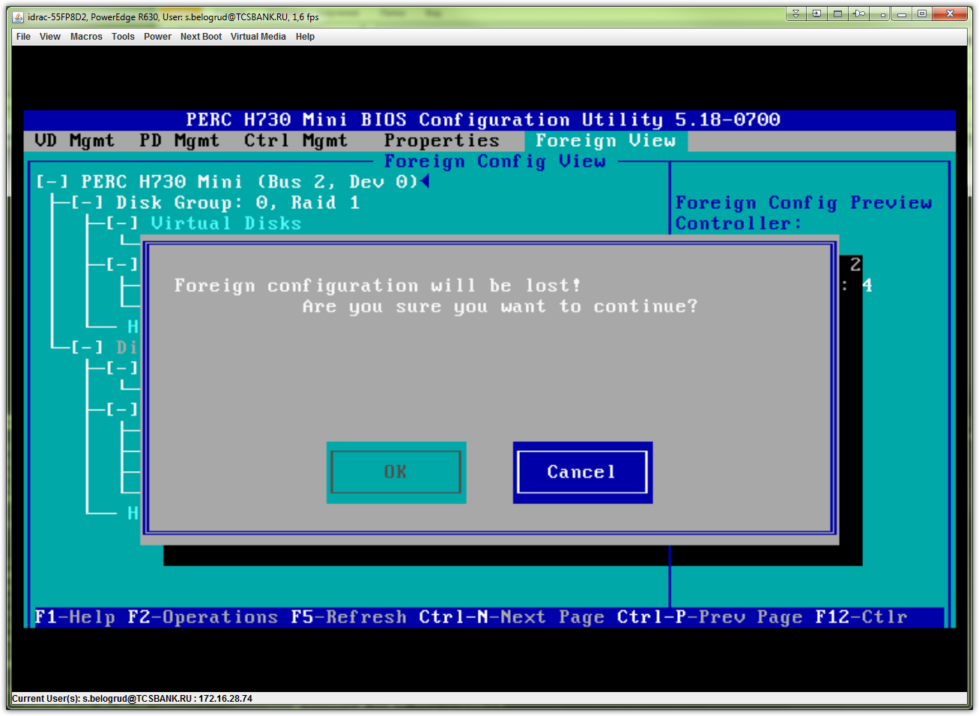

# As shown on this picture - two new HDD became white color and become available to use it.
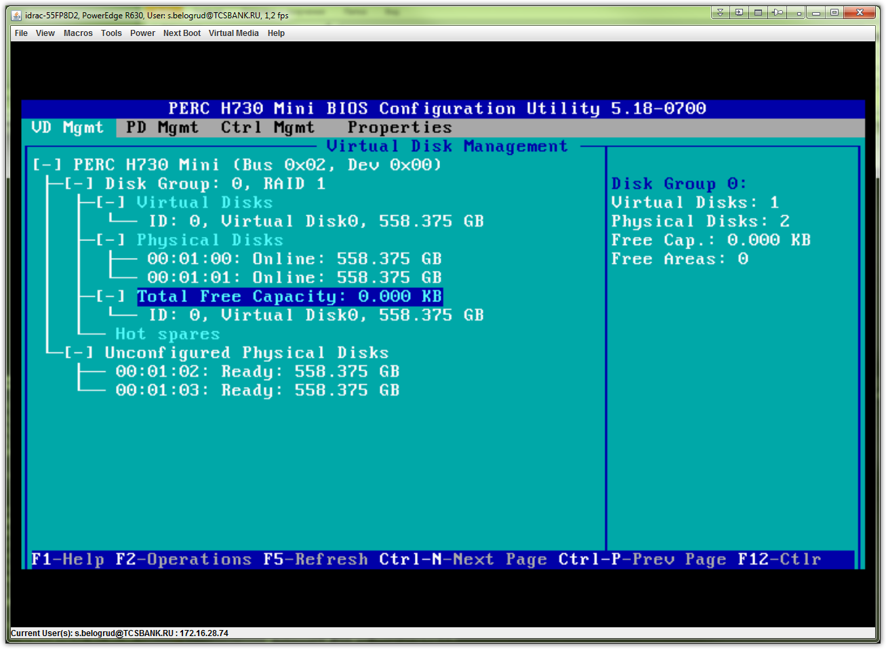

# In iDRAC these two drives became with green boxes.
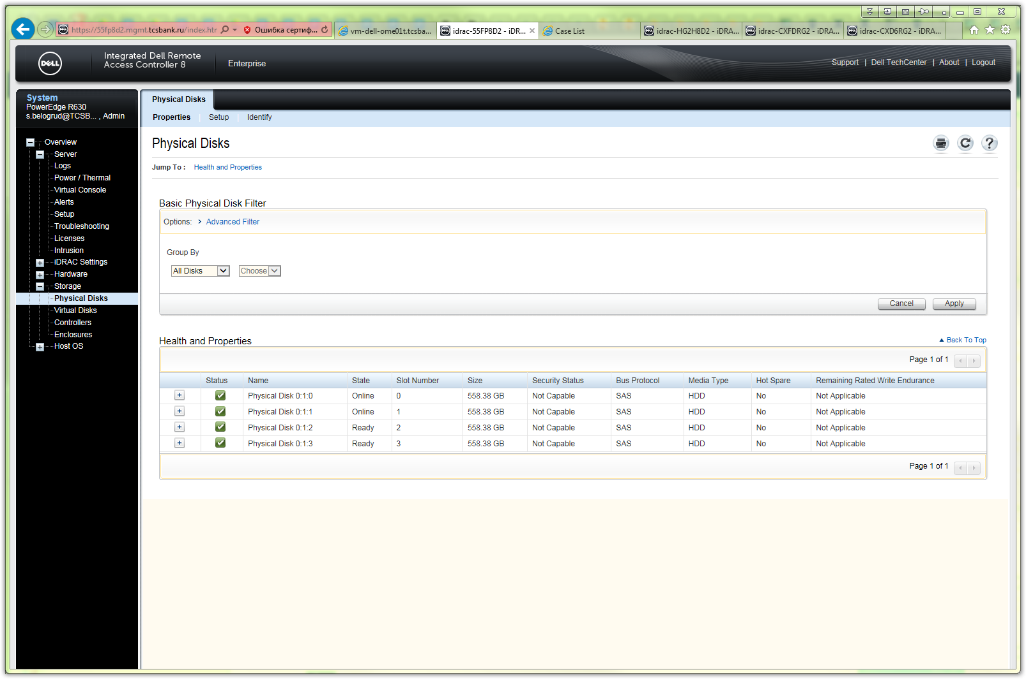

# At this momen I want to create new logical structure - new virtual drive for new two HDD with raid 1 (mirror).
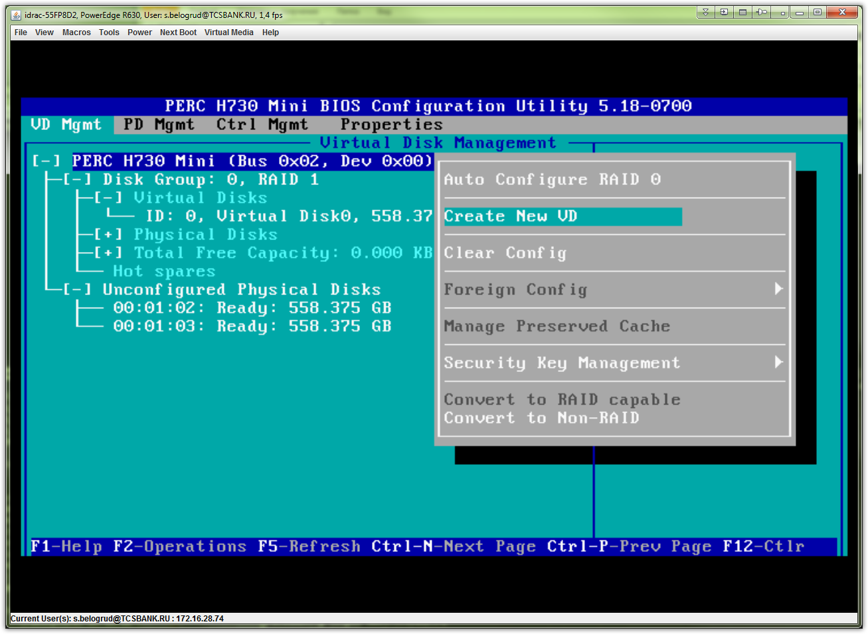

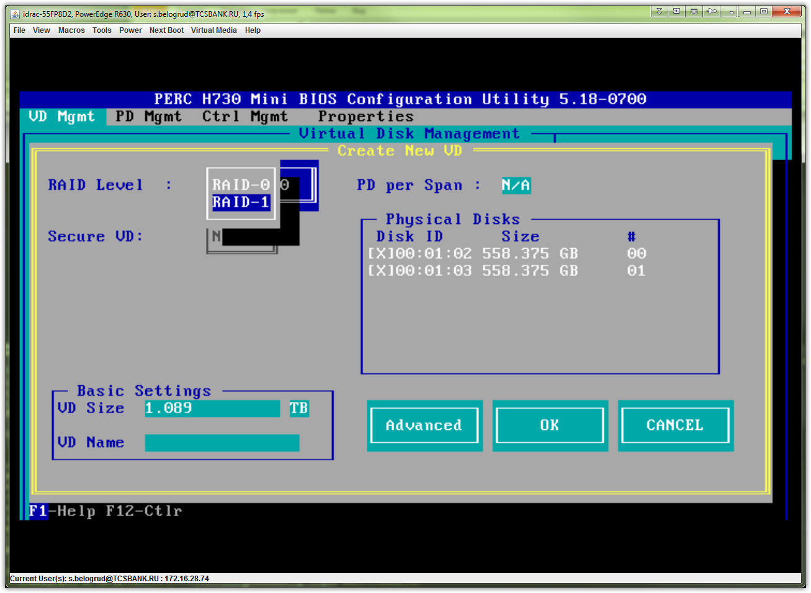

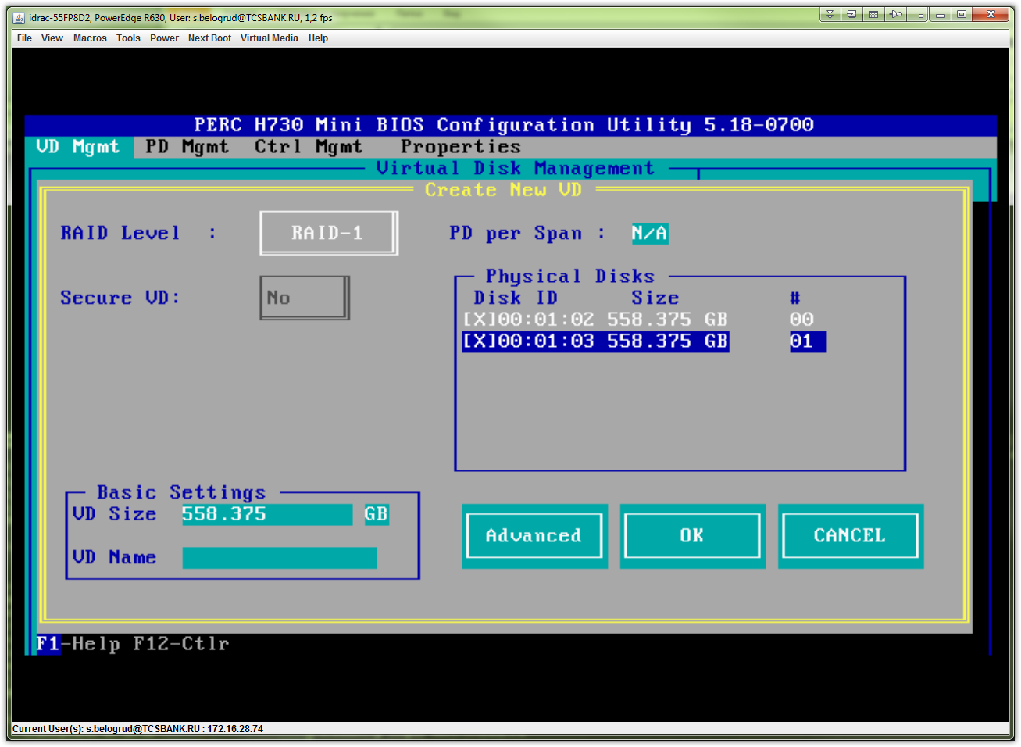

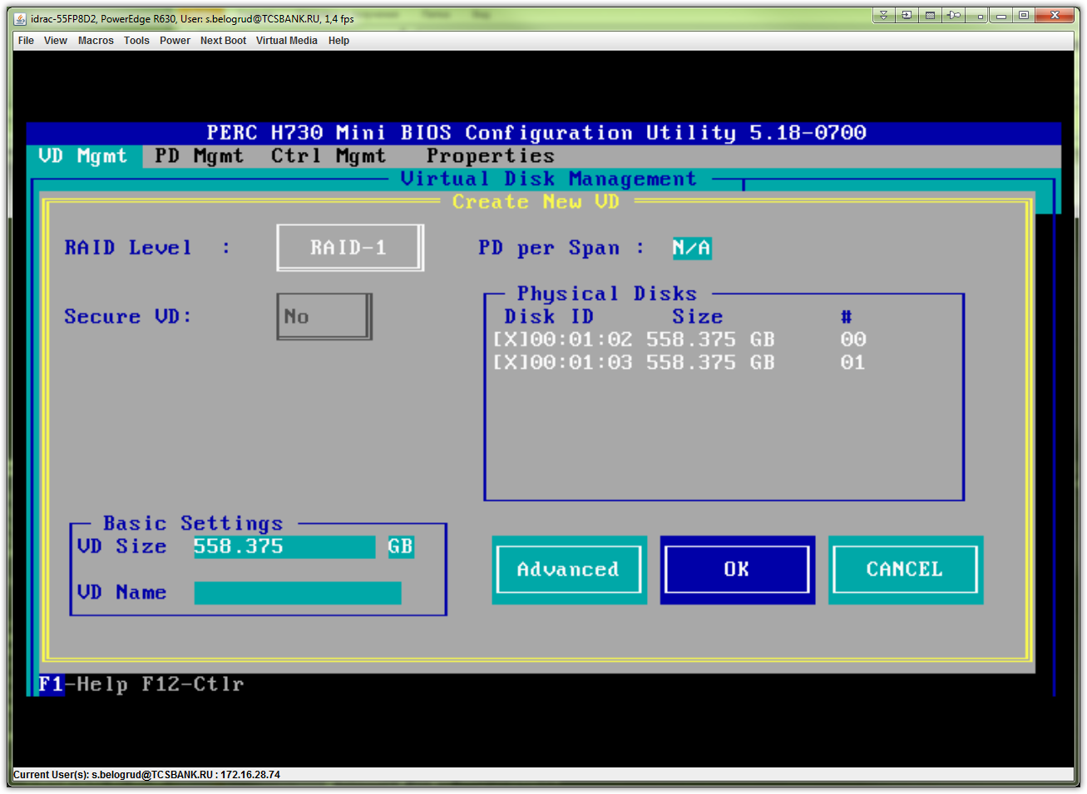

# It’s need to initialize hard drives.
# Follow is a note how I did it.
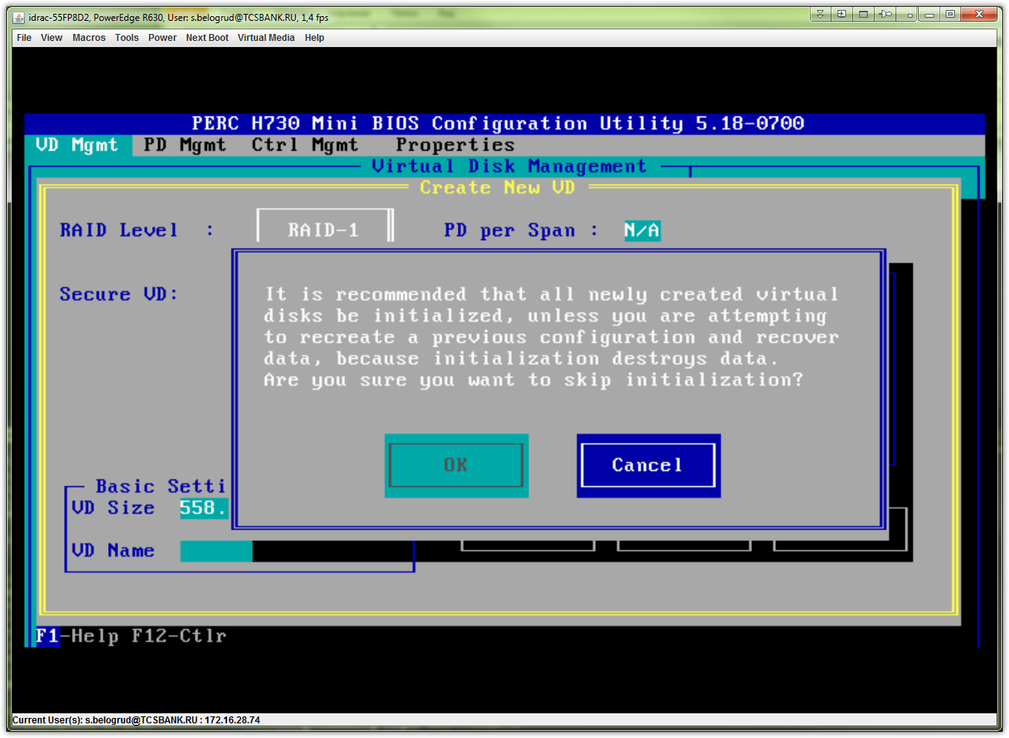

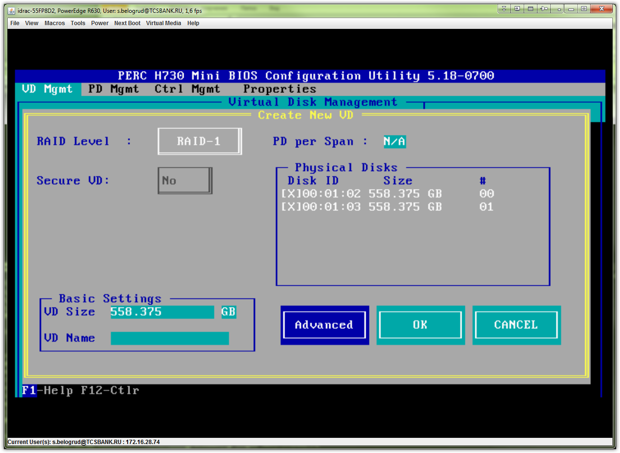

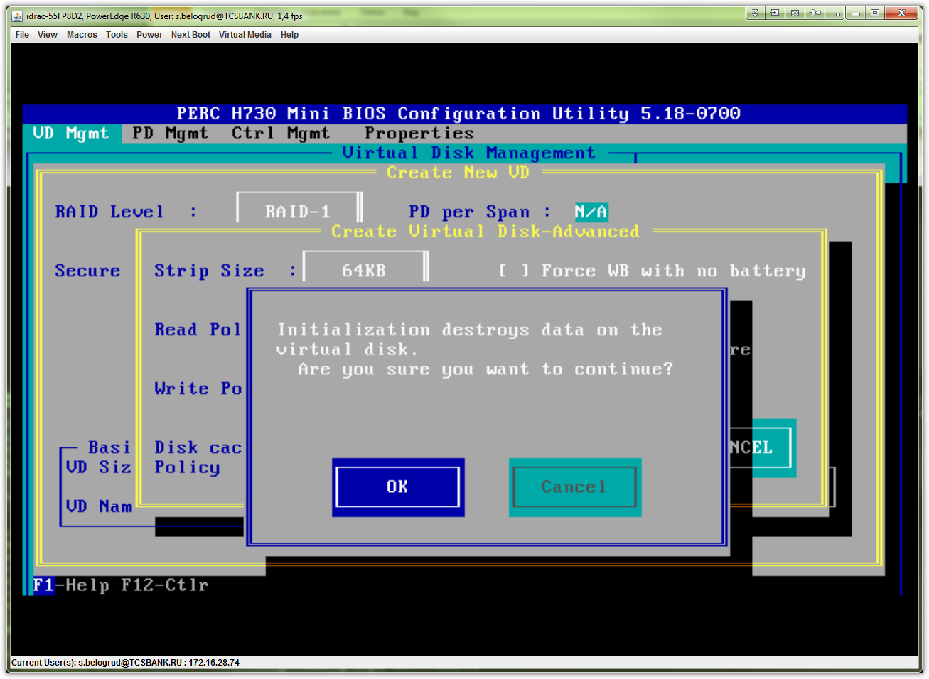

# Here I’ve choosed “Initialize” box and press “OK” button.
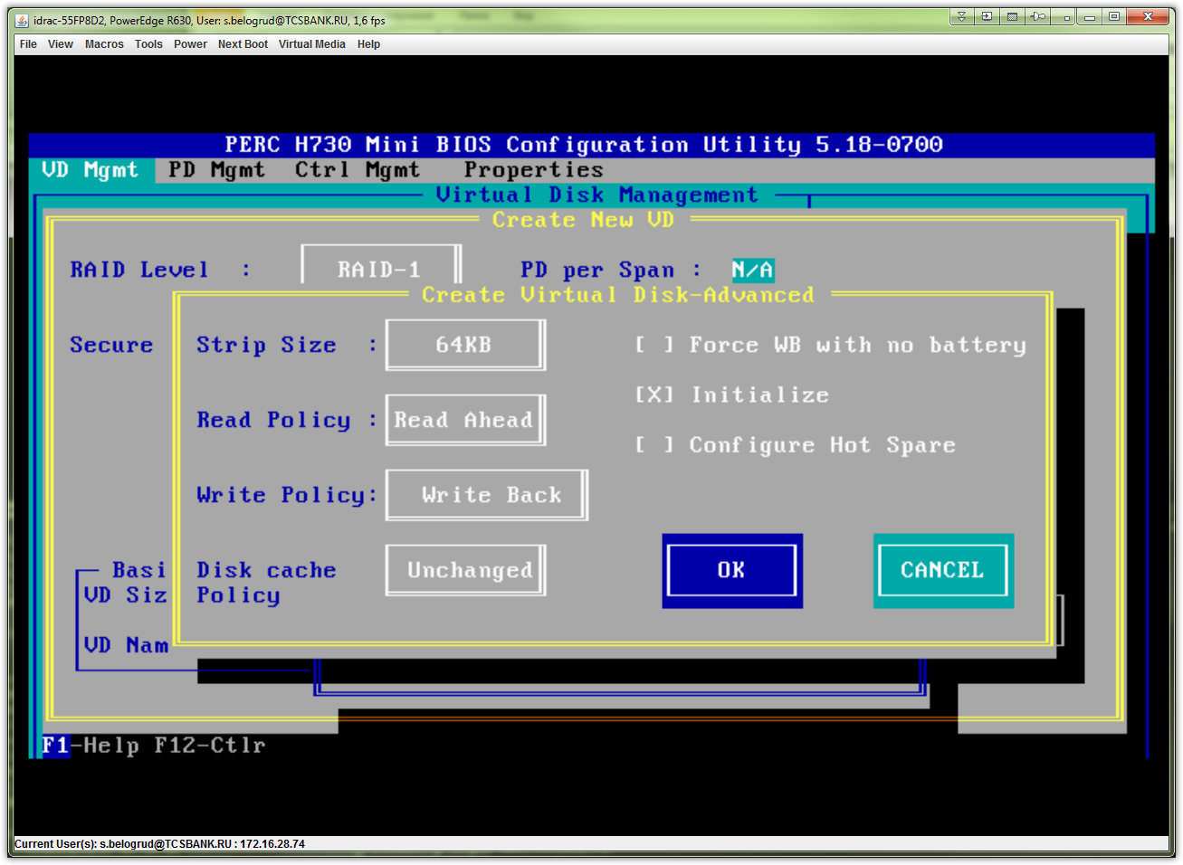

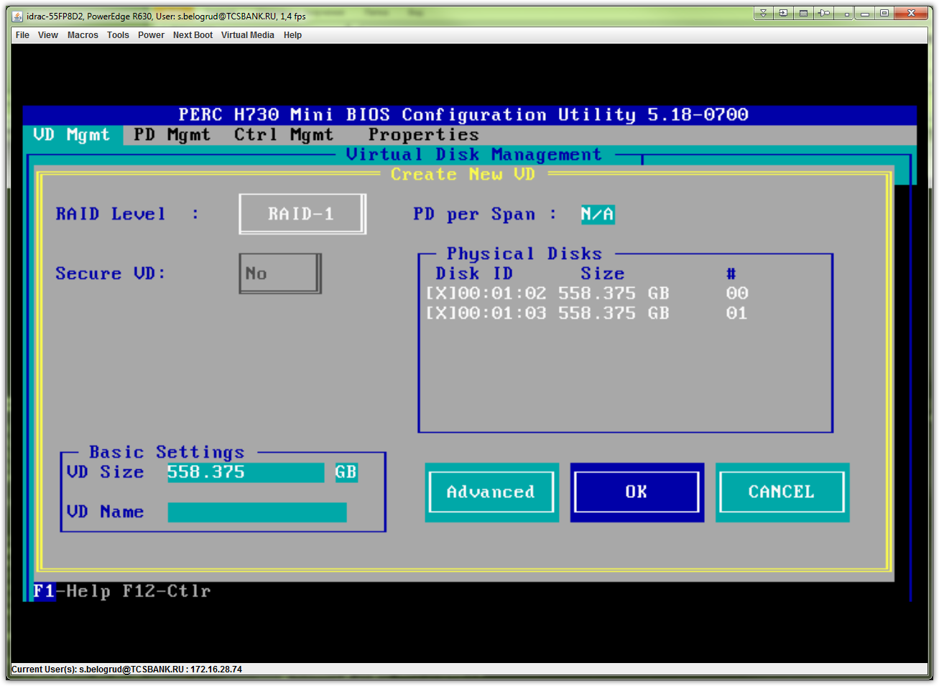

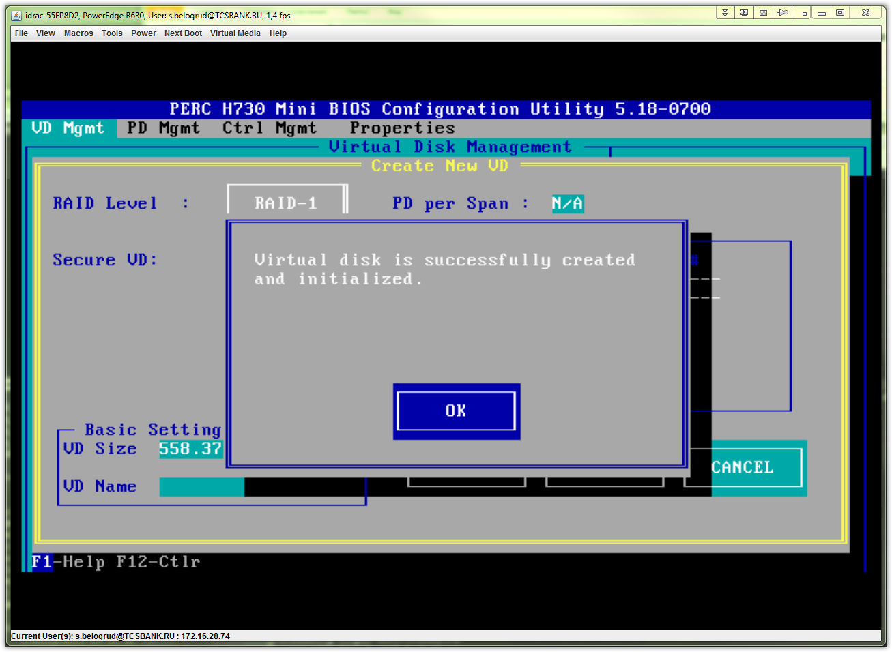

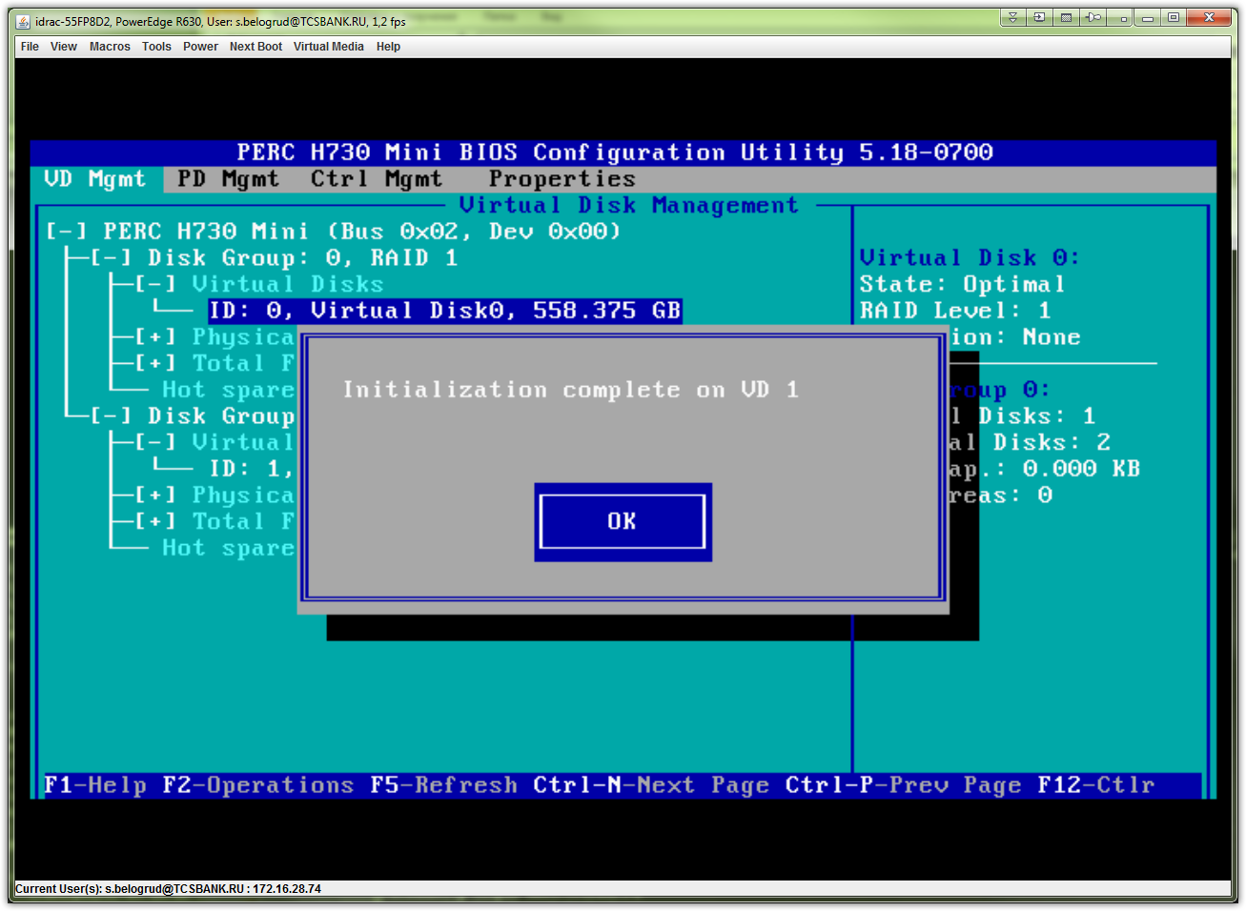

# That’s it!
# Here is how it looks, when everything is Ok.
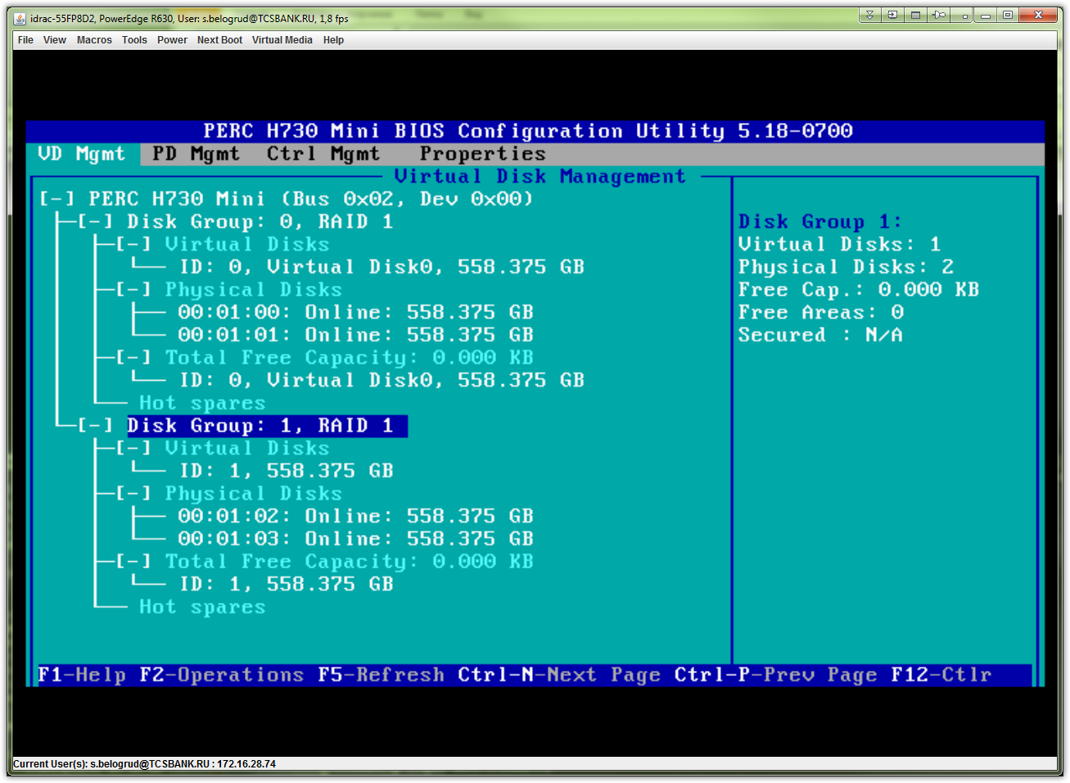

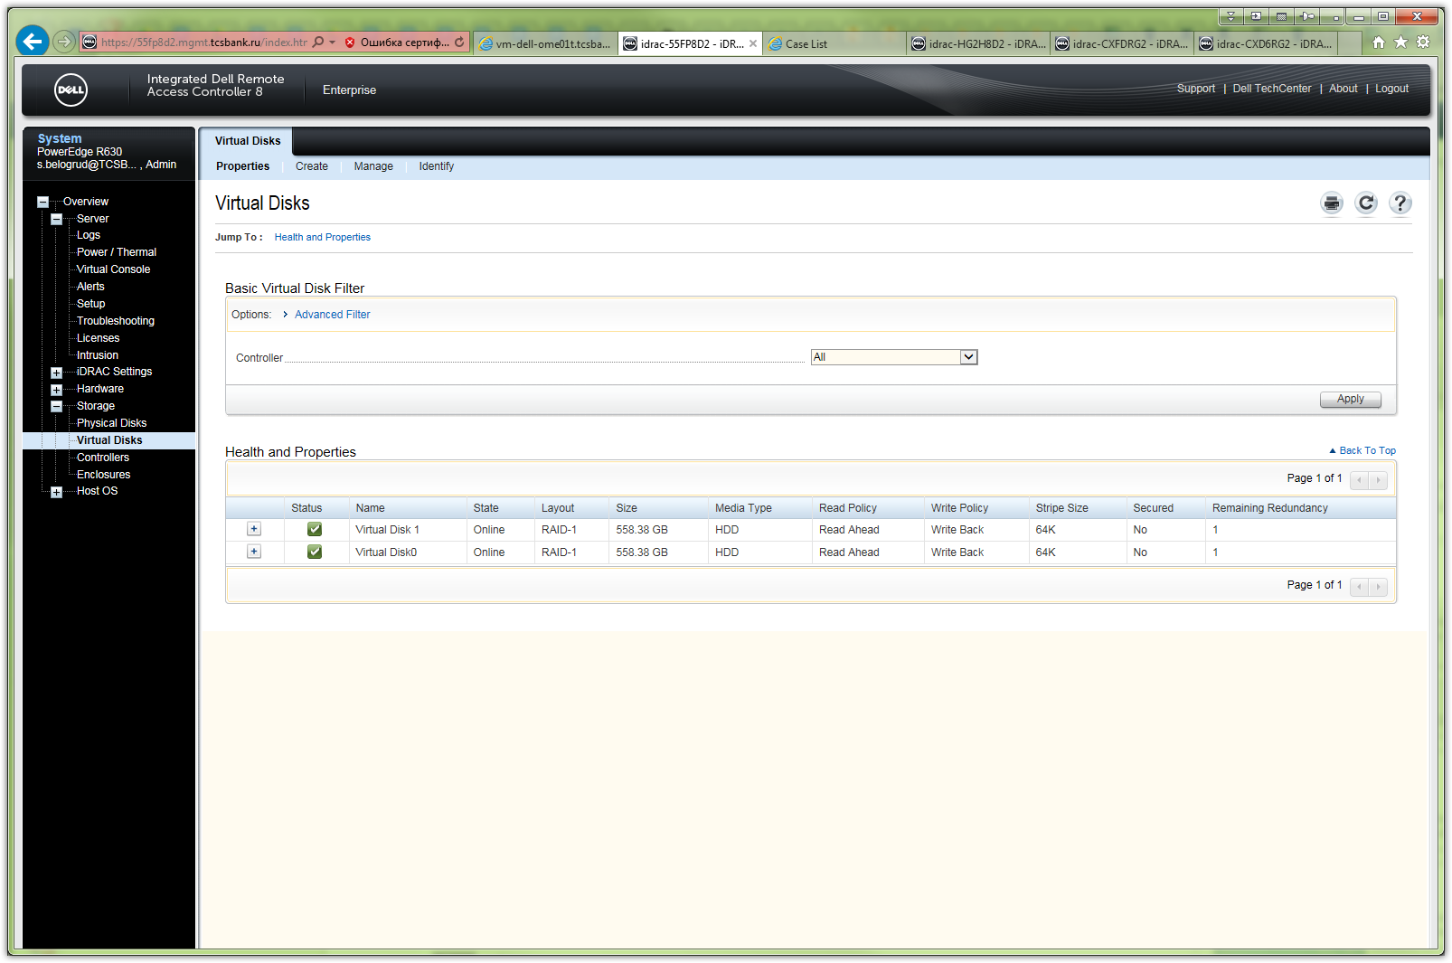

# Pressed “ESC” button to exit from raid configuration utility.
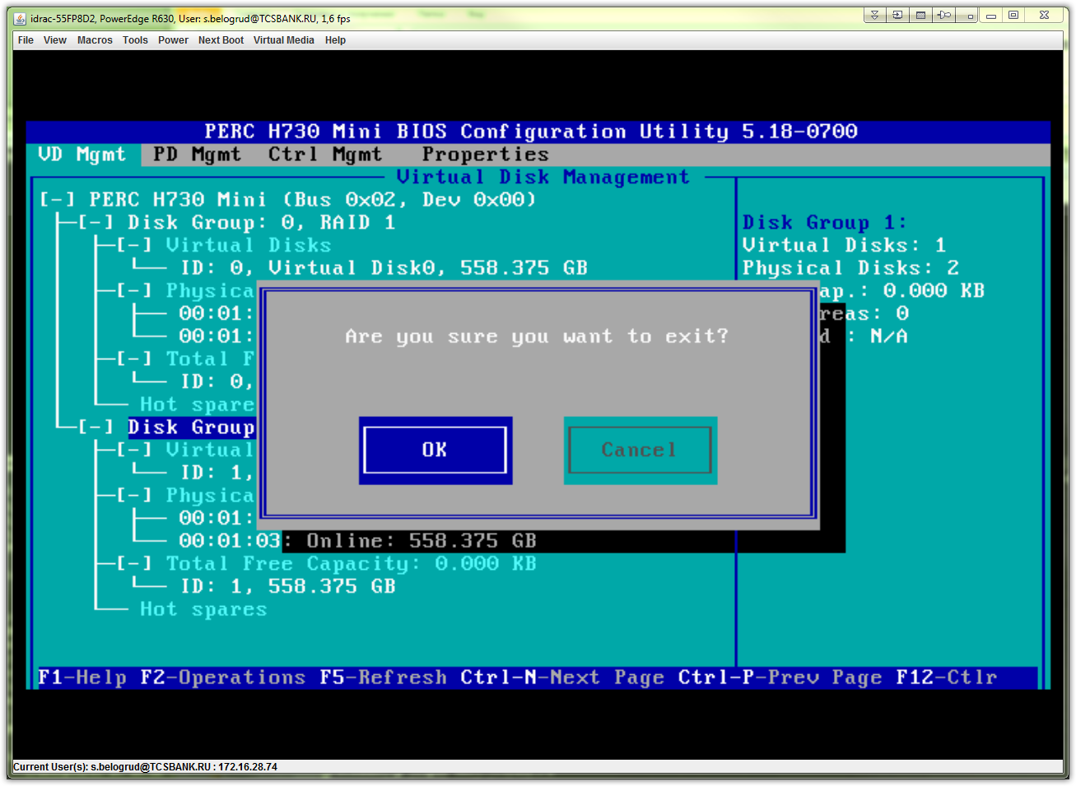

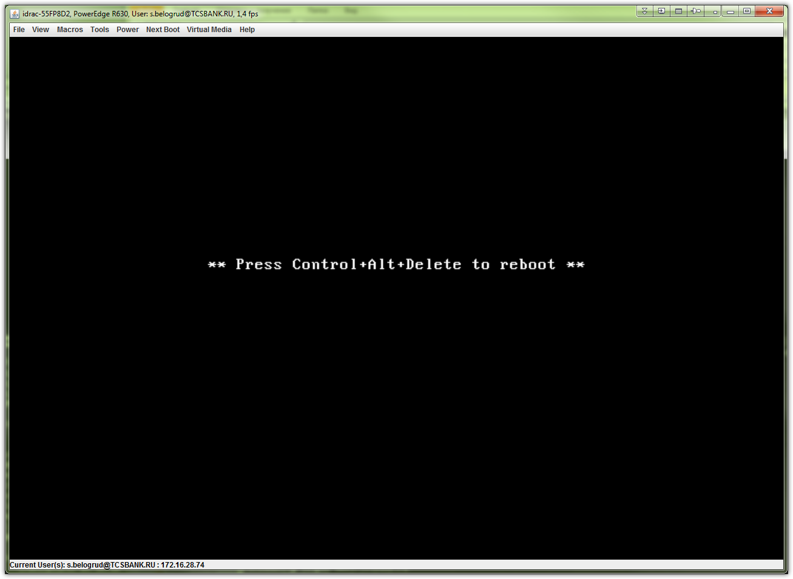

# Follow are wrong things, that I did.

# I had restarted iDRAC interfaces.
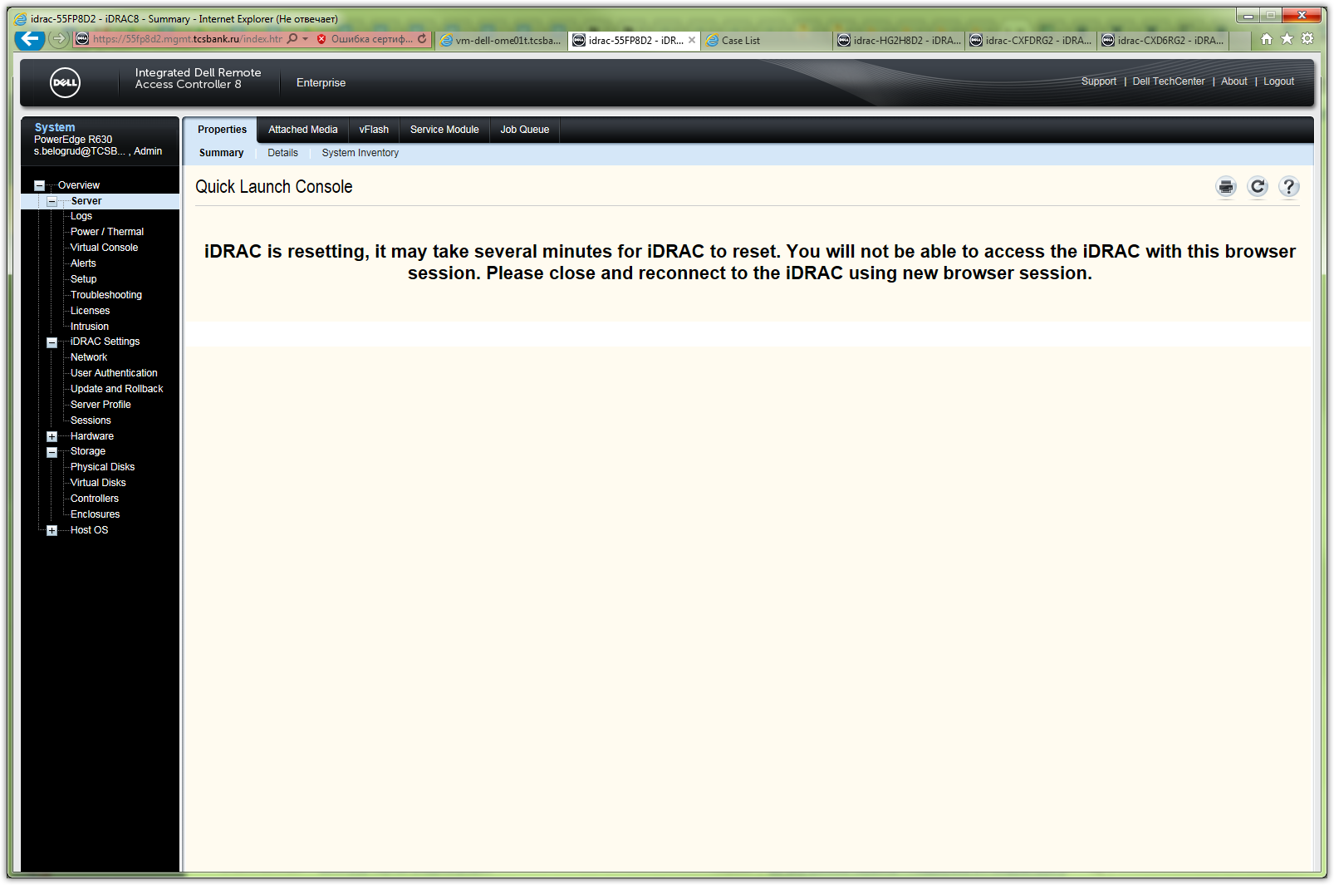

# I tried to press “F” button during boot process.
# It was wrong idea. It shouldn’t did.

# Below is, what error, what I received.
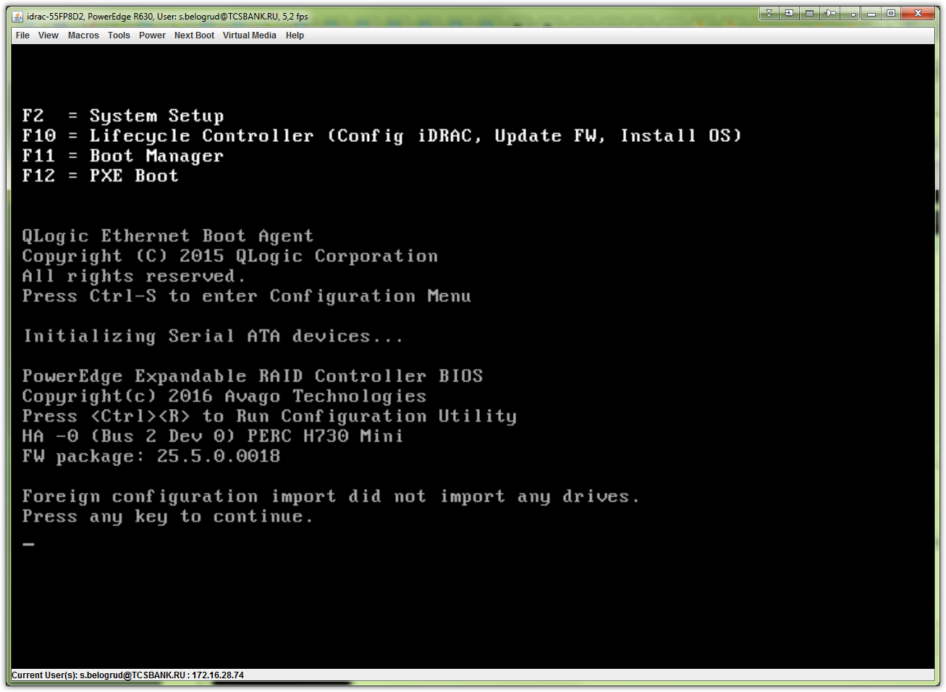

# Next wrong idea was to try do “import”.
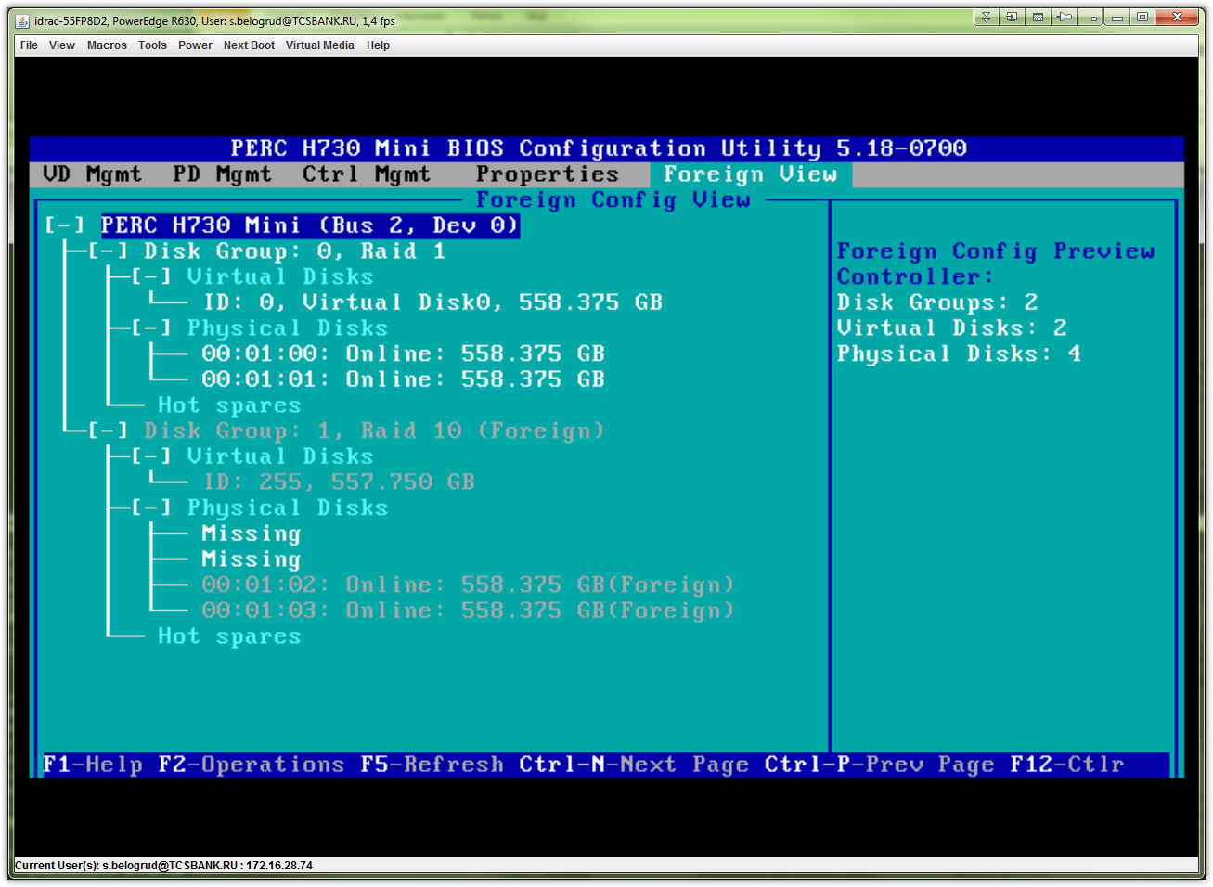
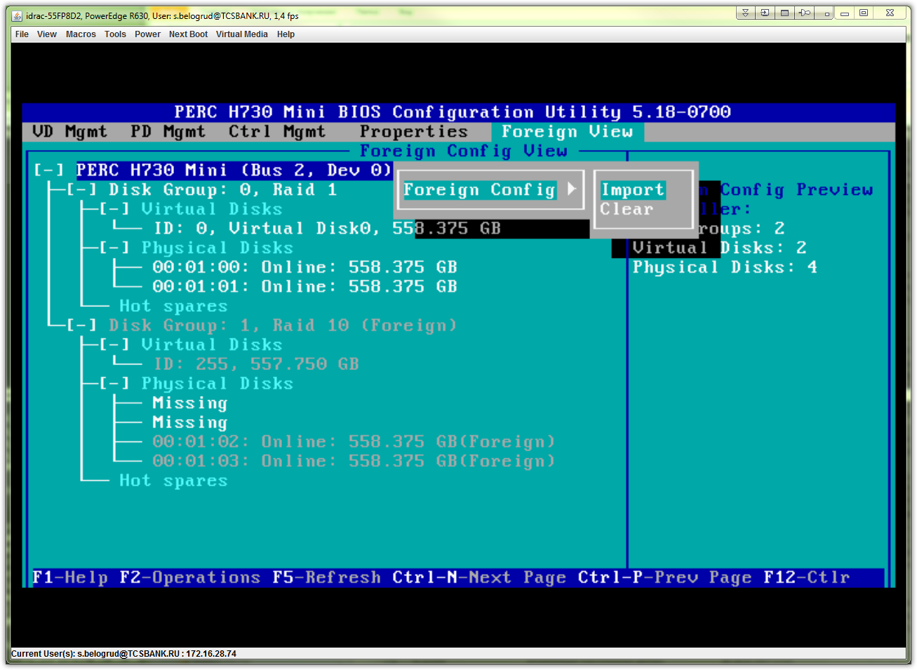
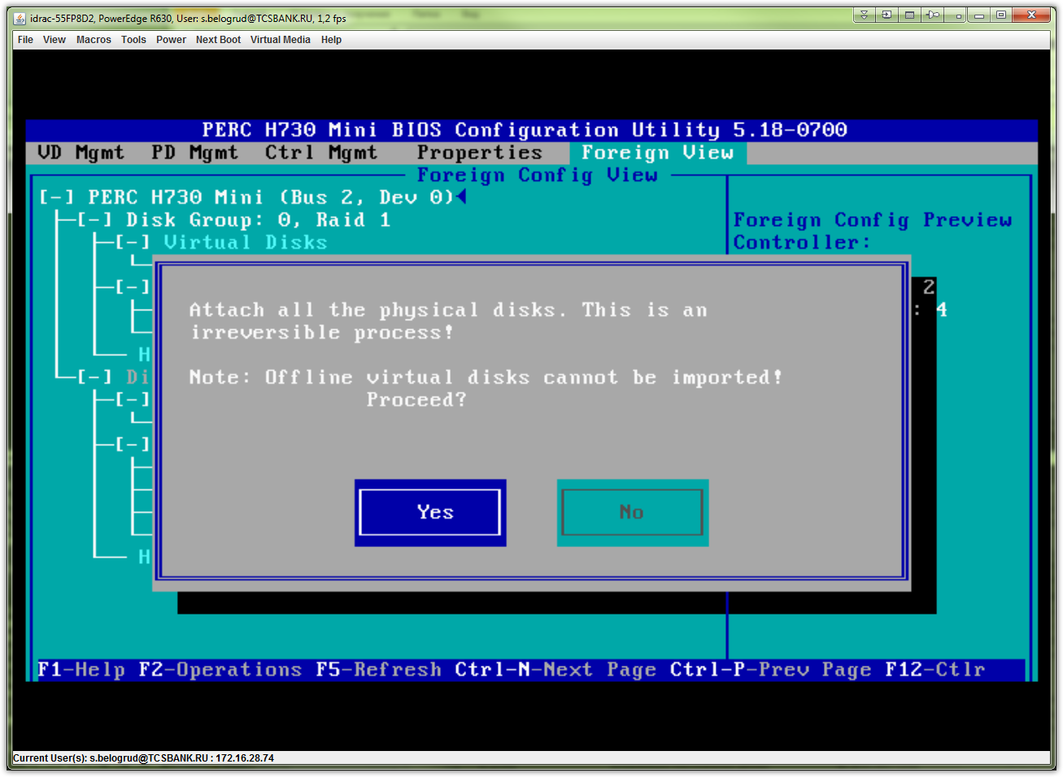
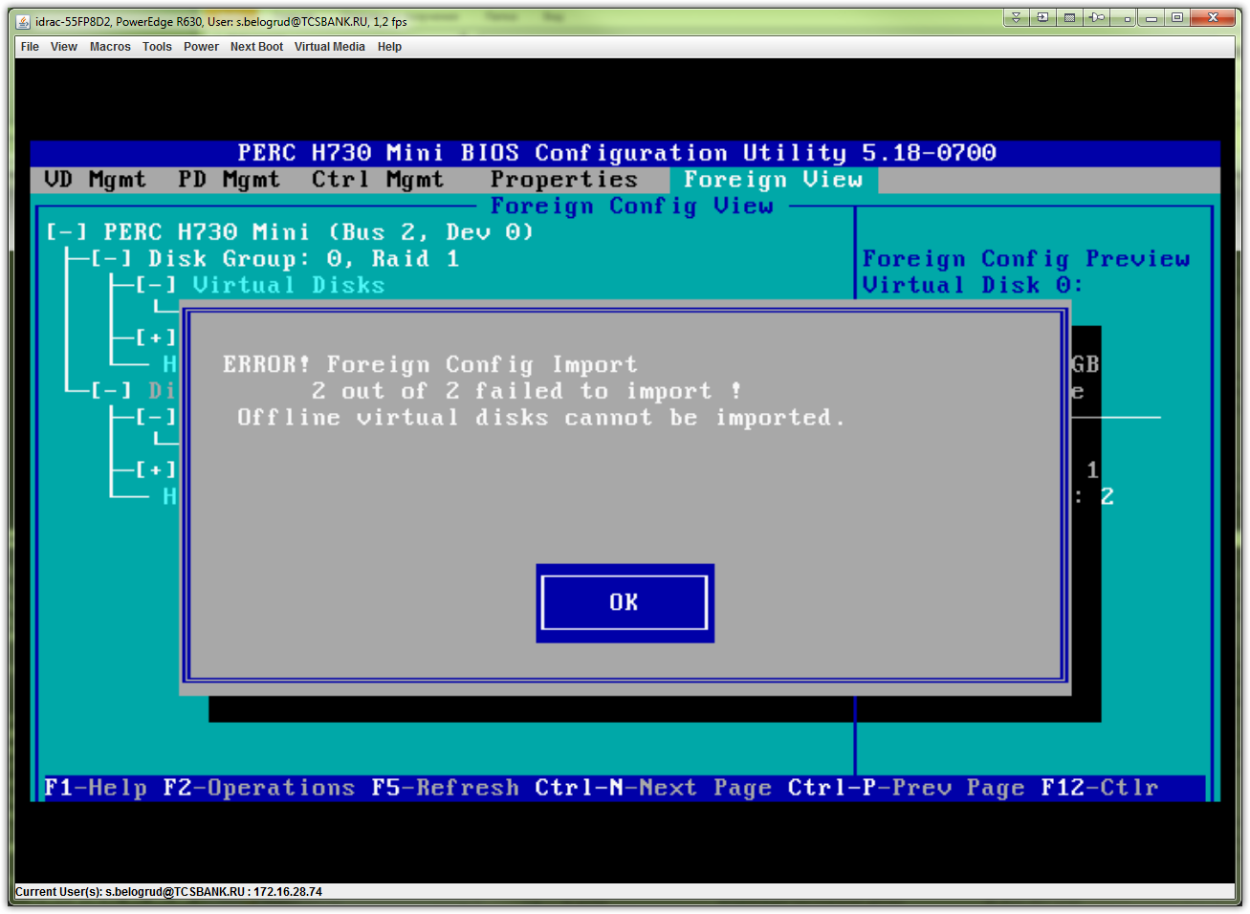

# Here is next wrong thing.
# This option should not be touched. Its right state is to be turned off - unchecked, as it exists by default.
